SUPPLY CHAIN & INVENTORY PERFORMANCE ANALYTICS
A Data Analytics Project Report

1. Project Overview
This project analyzes supply chain and inventory performance using operational transaction data. The analysis focuses
on demand patterns, inventory levels, warehouse capacity, supplier performance, transportation cost, order accuracy and
backorder activity. The objective is to transform raw operational data into clear business insights for inventory planning
and operational monitoring.
Business Objectives
• Measure overall sales volume, inventory levels and transportation expenditure.
• Compare demand across regions and product categories.
• Understand inventory distribution across warehouses.
• Present key KPIs and trends through an interactive Power BI dashboard.
2. Dataset Summary
The dataset contains 1,200 rows and 15 columns. It includes date, region, category, supplier, warehouse, order status and operational measures.
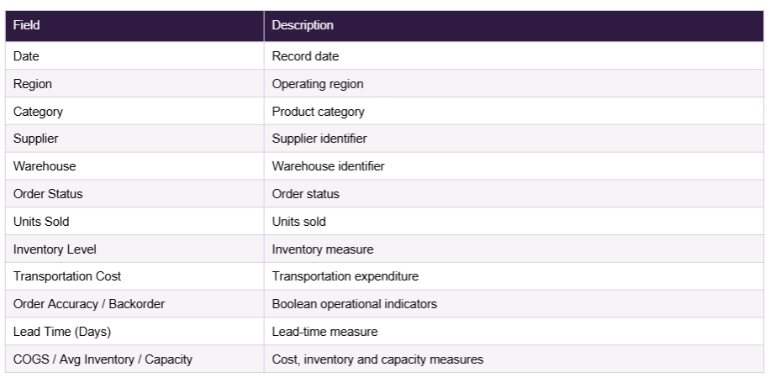
3. Exploratory Data Analysis using Python
Python was used as the initial analytical layer to load, inspect and explore the supply chain dataset before database analysis and dashboard development.
Data Preparation & Exploration
• Loaded the dataset using pandas and inspected its structure.
• Reviewed descriptive statistics and numerical fields.
• Checked operational Boolean fields such as Order Accuracy and Backorder.
• Examined demand, inventory, supplier and operational relationships.
• Prepared the analysis outputs used later for SQL and Power BI.
Key Exploratory Findings
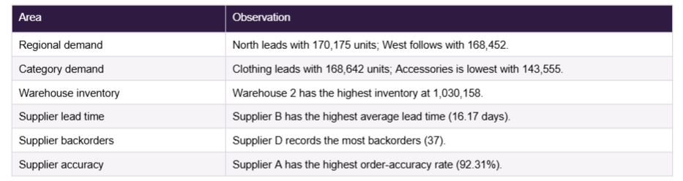

EDA Role
The Python stage established a structured understanding of the data and highlighted the measures and dimensions required for the final business dashboard
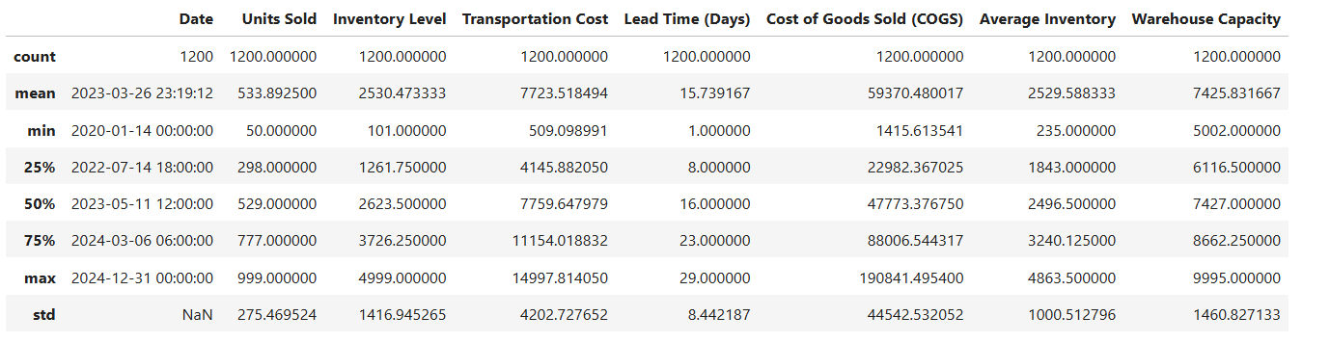
Monthly units sold Line chart
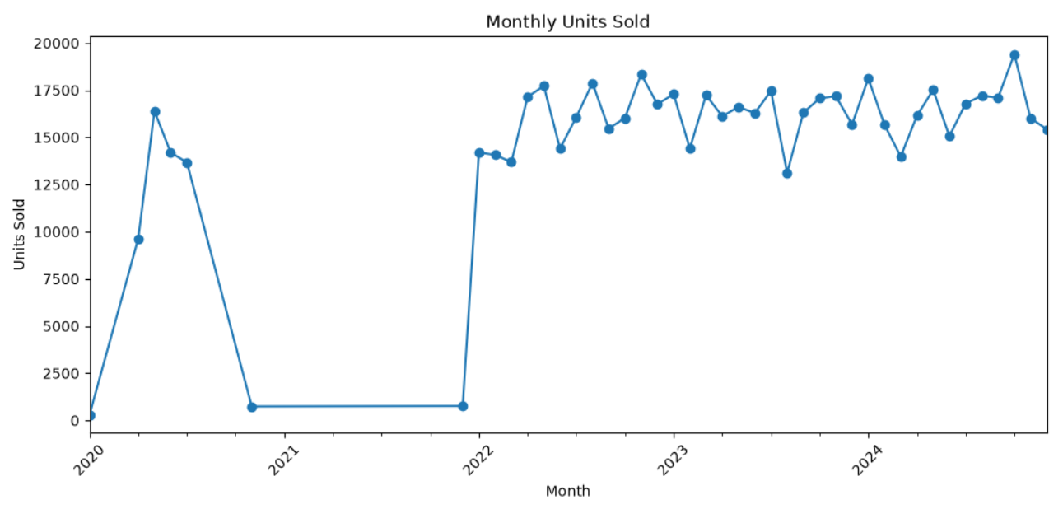
Inventory level vs units sold scatter chart
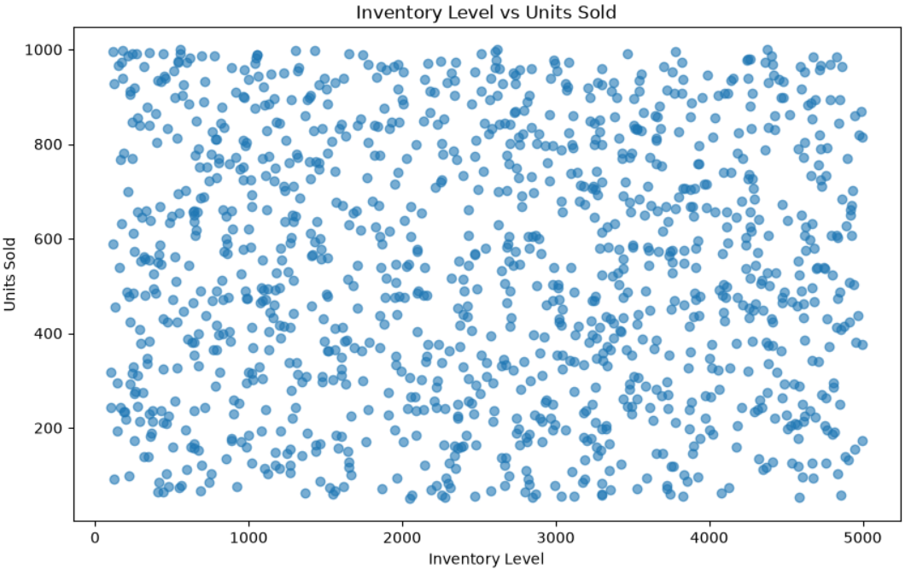

Correlation matrix
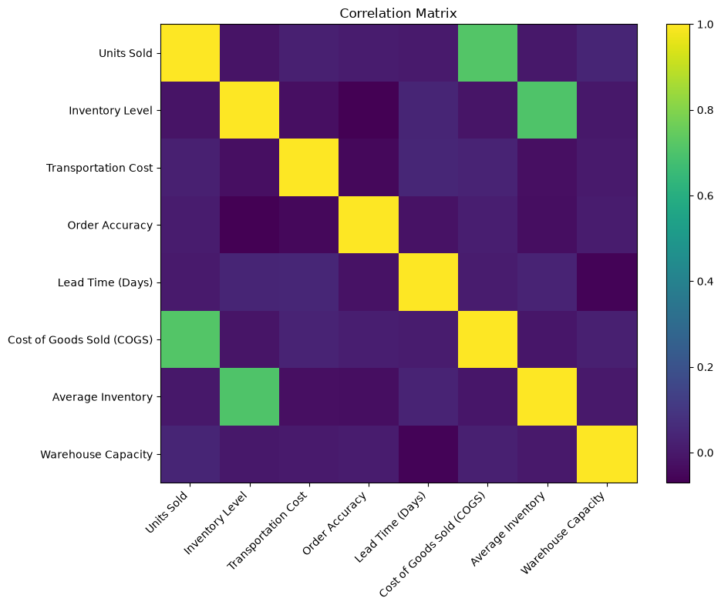
4. Data Analysis using SQL (Business Transactions)
PostgreSQL was used to create the supply_chain table, load the cleaned data and perform structured business analysis.The SQL workflow includes table creation, validation queries, KPI calculations and grouped analysis.
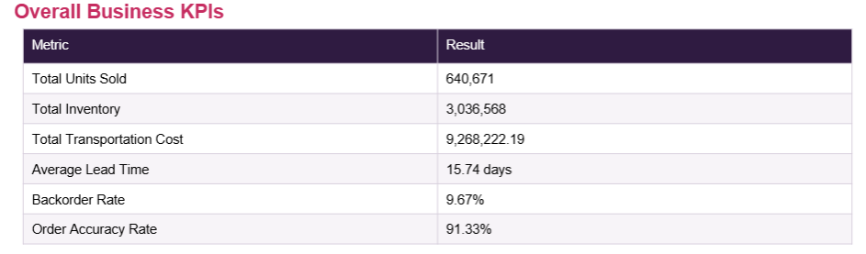
Business Transactions / Grouped Analysis
• Units sold by region.
• Units sold by category.
• Inventory by warehouse.
• Average supplier lead time.
• Backorders by supplier.
• Order accuracy by supplier.
SQL Techniques
The supplied SQL uses SUM, AVG, COUNT, CASE expressions, GROUP BY and ORDER BY to turn raw records into business-level metrics
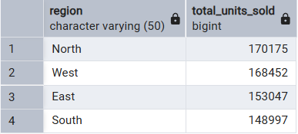

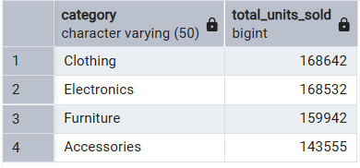

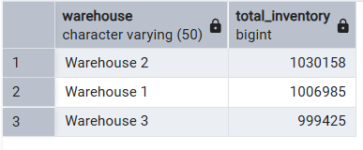
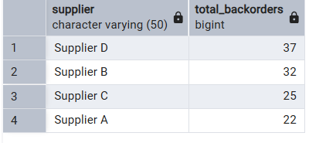

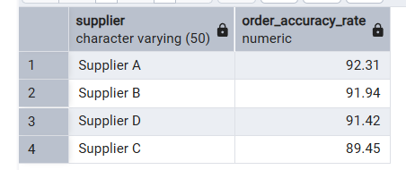

5. Dashboard in Power BI
Power BI is the final presentation layer. The report is organized into three pages so users can move from overall performance to inventory and warehouse analysis, then to supplier performance.
Page 1 — Executive OverviewPage
• KPI cards for Total Units Sold, Total Inventory, Total Transportation Cost, Average Lead Time and Backorder Rate.
• Monthly Units Sold trend, Units Sold by Region and Units Sold by Category.
• Slicers for Region, Category, Supplier, Warehouse and Order Status.
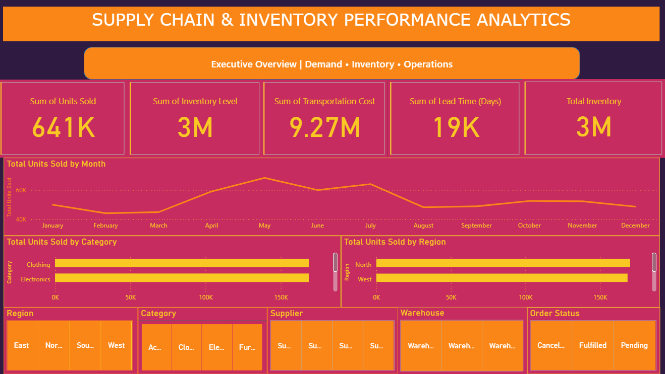
Page 2 — Inventory & Warehouse
• Capacity Utilization and Backorder Rate measures.
• Inventory by Warehouse and Inventory by Category.
• Inventory vs Units Sold scatter plot.
• Backorders by Warehouse.
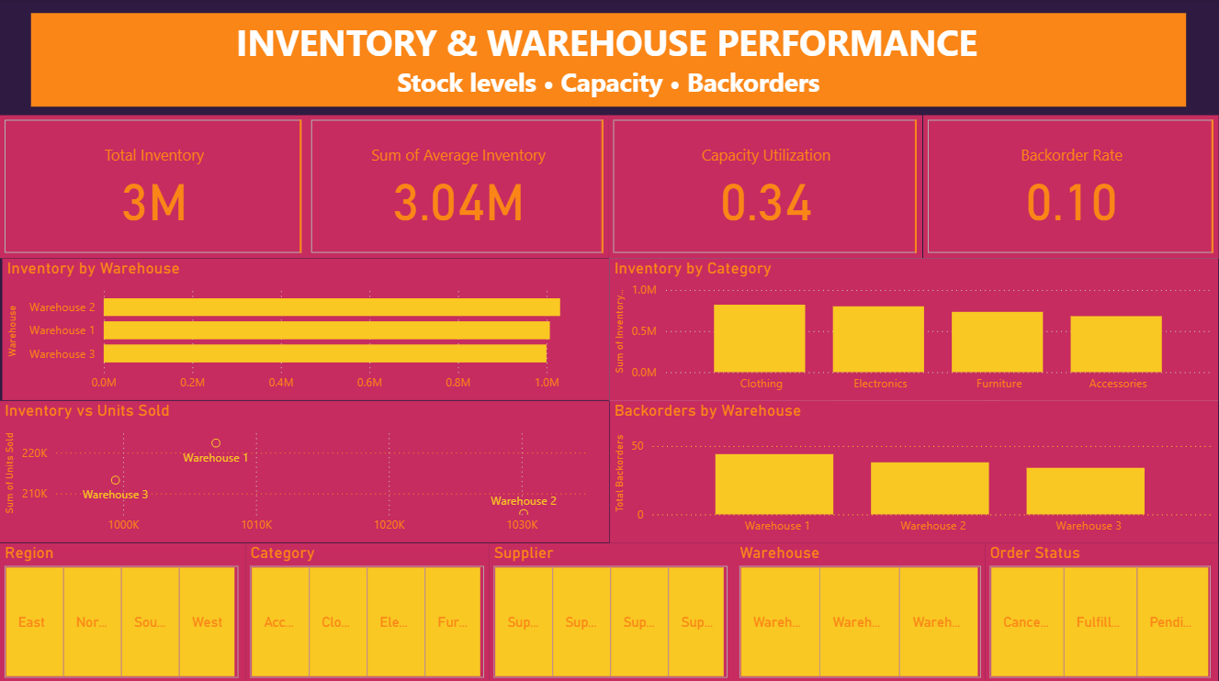
Page 3 — Supplier Performance
• Average Lead Time, Order Accuracy Rate, Total Backorders and Transportation Cost KPIs.
• Supplier Lead Time, Supplier Order Accuracy and Backorders by Supplier.
• Transportation Cost by Supplier.
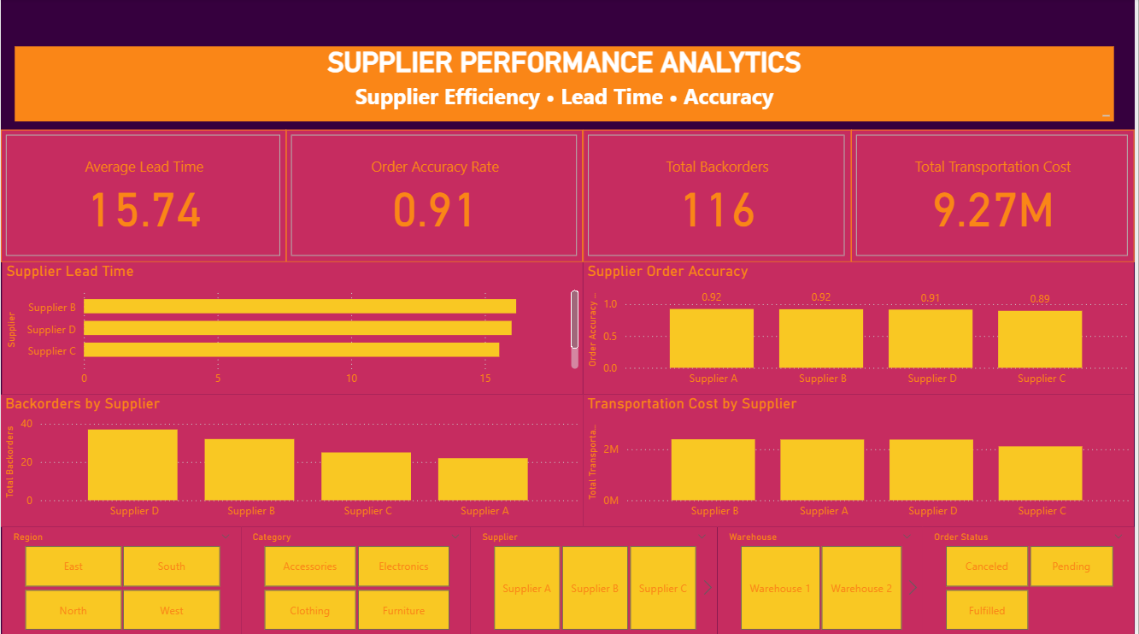
6. Business Insights
The combined Python, SQL and Power BI analysis provides the following operational observations.
Demand & Category
• Total demand is 640,671 units.
• North records the highest regional volume at 170,175 units, while South records 148,997.
• Clothing and Electronics record 168,642 and 168,532 units respectively.
Inventory & Warehouse
• Total inventory is 3,036,568 units.
• Warehouse 2 has the highest inventory concentration at 1,030,158 units.
• Inventory should be interpreted together with demand; the dashboard therefore includes an Inventory vs Units Sold comparison.
Supplier Performance
• Overall average lead time is 15.74 days.
• Supplier Supplier B has the highest average lead time at 16.17 days.
• Supplier Supplier D has the highest number of backorder records at 37.
• Overall order accuracy is 91.33%; supplier accuracy ranges from 89.45% to 92.31%.
Operational Risk
• Total transportation cost is 9,268,222.19.
• The overall backorder rate is 9.67%

7. Business Recommendations
The recommendations below are linked to the measured demand, inventory, supplier and operational indicators in the project.
1. Strengthen Inventory Planning
Use regional and category demand together with warehouse inventory levels to improve replenishment planning and reduce the risk of excess or insufficient stock.
2. Monitor Supplier Lead Time
Track supplier lead time regularly and investigate suppliers with consistently higher lead times, especially where long lead time is accompanied by higher backorder activity.
3. Reduce Backorder Risk
Use the Backorders by Supplier and Backorders by Warehouse views to identify recurring problem areas and prioritize operational review.
4. Improve Supplier Order Accuracy
Compare supplier accuracy rates periodically and use the dashboard to monitor changes. Lower-performing suppliers can be reviewed for process or fulfillment issues.
5. Control Transportation Cost
Monitor transportation expenditure by supplier and region. Combining cost with demand and service indicators can help identify operational efficiency opportunities

